For Books/PDF : mail to [rahulonlinetutor@gmail.com](mailto:rahulonlinetutor@gmail.com) see video 31

**Pre-Requisites:**

Make sure your Appium server is stared

Command in Command prompt : Appium

Make sure your Emulator is opened.

Command : Open the Emulator in cmd C:\Users\Nbarnana\AppData\Local\Android\Sdk\emulator

And enter the command emulator -avd emulatorname

My desired Capabilities:

1)Emulator : Open the Emulator

2)Invoke App

3)Connection step to server

4)Code

Android UI Automator Tool : used to inspect elements. It will be available in below location.

C:\Users\Nbarnana\AppData\Local\Android\Sdk\tools\bin

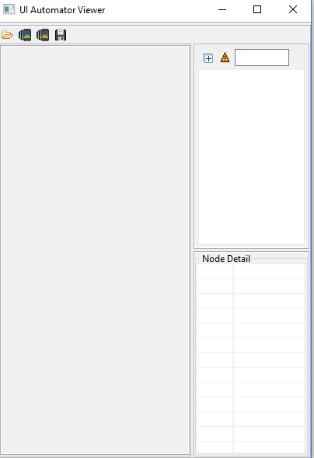

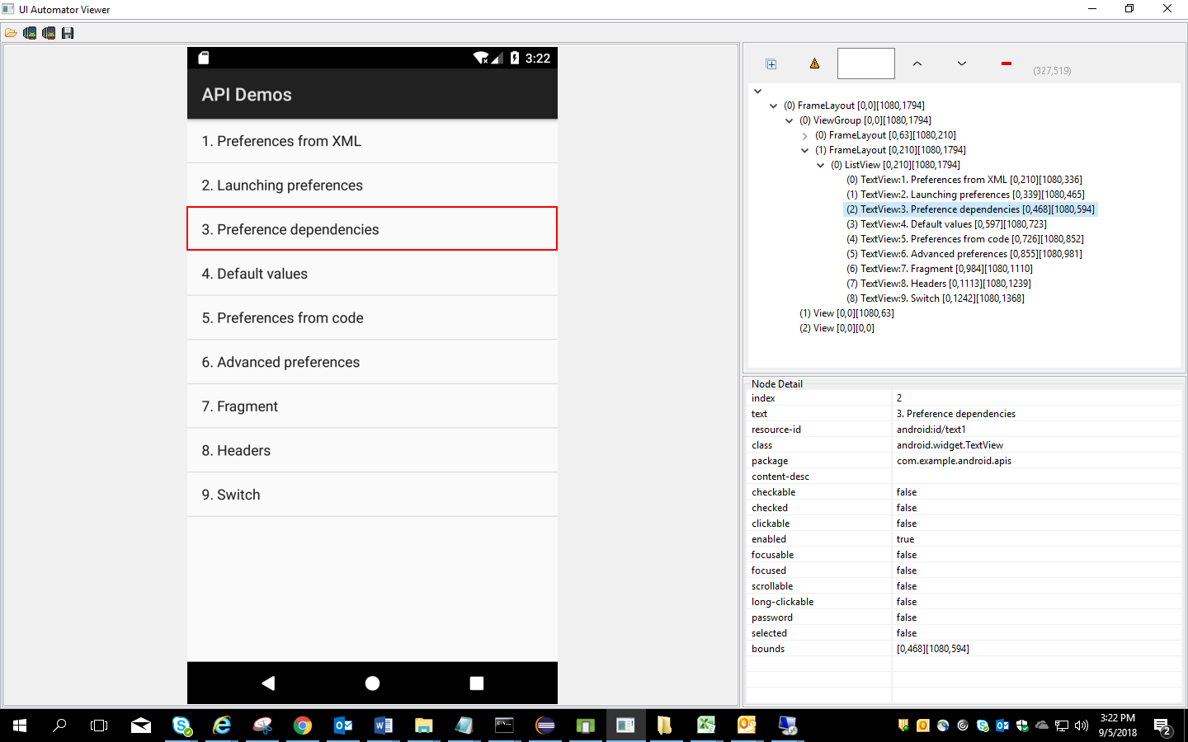

Open the Emulator first and then invoke the Android UI Automator

Locators used in Selenium:

1)xpath id

2)class name

3)androidUiAutomator

Basic program

package appiumTest;

import java.io.File;

import java.net.MalformedURLException;

import java.net.URL;

import java.util.concurrent.TimeUnit;

import org.openqa.selenium.remote.DesiredCapabilities;

import io.appium.java_client.android.AndroidDriver;

import io.appium.java_client.android.AndroidElement;

import io.appium.java_client.remote.MobileCapabilityType;

public class BaseClass {

public static AndroidDriver<AndroidElement> Capabilities() throws MalformedURLException {

File f=new File("src");

File fs=new File(f,"ApiDemos-debug.apk");

DesiredCapabilities cap= new DesiredCapabilities();

cap.setCapability(MobileCapabilityType.DEVICE_NAME, "NarayanaEmulator1");

cap.setCapability(MobileCapabilityType.APP, fs.getAbsolutePath());

//Connection to the server

//AndroidDriver driver=new AndroidDriver(conection to the server link, capability object);

//We are working on Android server so we are selection AndroidDriver

//http://127.0.0.1: is common for both android and ios server and 4723 is appium server which you are working

AndroidDriver<AndroidElement> driver=new AndroidDriver<>(new URL("http://127.0.0.1:4723/wd/hub"),cap);

return driver;

//System.out.println("Program executed sucessfully");

}

}

**package** appiumTest;

**import** java.net.MalformedURLException;

**import** java.util.concurrent.TimeUnit;

**import** org.openqa.selenium.By;

**import** io.appium.java_client.android.AndroidDriver;

**import** io.appium.java_client.android.AndroidElement;

**public** **class** IdentifyingElements **extends** BaseClass{

**public** **static** **void** main(String[] args) **throws** MalformedURLException {

AndroidDriver<AndroidElement> driver=*Capabilities*();

driver.manage().timeouts().implicitlyWait(10, TimeUnit.***SECONDS***);

//xpath id, class name and androidUiAutomator

driver.findElement(By.*xpath*("//android.widget.TextView[@text='Preference']")).click();

driver.findElement(By.*xpath*("//android.widget.TextView[@text='3. Preference dependencies']")).click();

driver.findElement(By.*id*("android:id/checkbox")).click();

driver.findElement(By.*xpath*("//android.widget.TextView[@text='WiFi settings']")).click();

//driver.findElement(By.id("android:id/edit")).sendKeys("Hello");

driver.findElement(By.*className*("android.widget.EditText")).sendKeys("Hello");

driver.findElement(By.*xpath*("//android.widget.Button[@text='OK']")).click();

}

}

How to Work with Android UI Automator locator :

driver.findElementByAndroidUIAutomator("attribute(“value”)");

//Java doesn’t accept quotes inside the quotes. so we have to use \

driver.findElementByAndroidUIAutomator("text(\"Views\")").click();

/validate all clickable options in Views tab

System.***out***.println(driver.findElementsByAndroidUIAutomator("new UiSelector().clickable(true)").size());

**Gestures in Appium :** To work on Gestures in Appium we use Touch Actions class

Below are the core Gestures in Appium Android and IOS

Tap, Press and release, scroll ,swipe and drag down

**1)Tap and press and release in Appium:**

**package** appiumTest;

**import** java.net.MalformedURLException;

**import** java.time.Duration;

**import** java.util.concurrent.TimeUnit;

**import** io.appium.java_client.MobileElement;

**import** io.appium.java_client.PerformsTouchActions;

**import** io.appium.java_client.TouchAction;

**import** org.openqa.selenium.By;

**import** org.openqa.selenium.interactions.touch.TouchActions;

//import io.appium.java_client.TouchAction;

**import** io.appium.java_client.android.AndroidDriver;

**import** io.appium.java_client.android.AndroidElement;

**import** io.appium.java_client.touch.TapOptions;

**import** io.appium.java_client.touch.WaitOptions;

**import** io.appium.java_client.touch.offset.ElementOption;

**public** **class** Gestures **extends** BaseClass{

**public** **static** **void** main(String[] args) **throws** MalformedURLException {

AndroidDriver<AndroidElement> driver=*Capabilities*();

driver.findElementByAndroidUIAutomator("text(\"Views\")").click();

//Tapping on element

TouchAction t=**new** TouchAction<>(driver);//.tap(TapOptions.tapOptions().withElement(ElementOption.element(driver.findElementByAndroidUIAutomator("text(\"Expandable Lists\")")))).perform();

t.tap(TapOptions.*tapOptions*().withElement(ElementOption.*element*(driver.findElementByAndroidUIAutomator("text(\"Expandable Lists\")")))).perform();

//Clicking on Custom Adapter

driver.findElement(By.*xpath*("//android.widget.TextView[@text='1. Custom Adapter']")).click();

driver.findElement(By.*xpath*("//android.widget.TextView[@text='People Names']"));

//How to press the element for 5 second

t.press(ElementOption.*element*(driver.findElement(By.*xpath*("//android.widget.TextView[@text='People Names']")))).waitAction(**new** WaitOptions().withDuration(Duration.*ofSeconds*(5))).release().perform();

driver.findElement(By.*xpath*("//android.widget.TextView[@text='Sample action']")).click();

}

}

**Swipe in Appium:**

package appiumTest;

import java.net.MalformedURLException;

import java.time.Duration;

import java.util.concurrent.TimeUnit;

import org.openqa.selenium.By;

import io.appium.java_client.TouchAction;

import io.appium.java_client.android.AndroidDriver;

import io.appium.java_client.android.AndroidElement;

import io.appium.java_client.touch.WaitOptions;

import io.appium.java_client.touch.offset.ElementOption;

public class SwipeGesture extends BaseClass{

public static void main(String[] args) throws MalformedURLException {

AndroidDriver<AndroidElement> driver=Capabilities();

driver.manage().timeouts().implicitlyWait(5, TimeUnit.SECONDS);

driver.findElementByAndroidUIAutomator("text(\"Views\")").click();

driver.findElement(By.xpath("//android.widget.TextView[@text='Date Widgets']")).click();

//driver.findElementByAndroidUIAutomator("text(\"Date Widgets\")").click();

//xpath will not work if the tag name has special character like $ so we need to use either below or findElementByAndroidUIAutomator

//driver.findElement(By.xpath("\\*[@text='Date Widgets']")).click();

driver.findElementByAndroidUIAutomator("text(\"2. Inline\")").click();

driver.findElement(By.xpath("//*[@content-desc='9']")).click();

//Swipe gesture : using moveTo option we can swipe

TouchAction t=new TouchAction<>(driver);

t.press(ElementOption.element(driver.findElement(By.xpath("//*[@content-desc='15']")))).waitAction(new WaitOptions().withDuration(Duration.ofSeconds(5))).moveTo(ElementOption.element(driver.findElement(By.xpath("//*[@content-desc='45']")))).release().perform();

System.out.println(driver.findElement(By.id("android:id/time_header")).getText());

}

}

*****************************************************************************

**Scroll Down in Appium:** *By using AndroidUIAutomator*

**package** appiumTest;

**import** java.net.MalformedURLException;

**import** java.util.concurrent.TimeUnit;

**import** io.appium.java_client.android.AndroidDriver;

**import** io.appium.java_client.android.AndroidElement;

**public** **class** ScrollGesture **extends** BaseClass{

**public** **static** **void** main(String[] args) **throws** MalformedURLException {

AndroidDriver<AndroidElement> driver=*Capabilities*();

driver.manage().timeouts().implicitlyWait(5, TimeUnit.***SECONDS***);

driver.findElementByAndroidUIAutomator("text(\"Views\")").click();

//Appium is

//**driver.findElementByAndroidUIAutomator("new UiScrollable(new UiSelector()).scrollIntoView(text(\"WebView\"));");**

**driver.findElementByAndroidUIAutomator("new UiScrollable(new UiSelector()).scrollIntoView(text(\"Radio Group\"));");**

System.***out***.println("Scrolled succesfully");

}

}

**Drag and Drop in Appium:**

**package** appiumTest;

**import** java.net.MalformedURLException;

**import** java.util.concurrent.TimeUnit;

**import** org.openqa.selenium.By;

**import** io.appium.java_client.TouchAction;

**import** io.appium.java_client.android.AndroidDriver;

**import** io.appium.java_client.android.AndroidElement;

**import** io.appium.java_client.touch.offset.ElementOption;

**public** **class** DragAndDrop **extends** BaseClass{

**public** **static** **void** main(String[] args) **throws** MalformedURLException {

AndroidDriver<AndroidElement> driver=*Capabilities*();

driver.manage().timeouts().implicitlyWait(5, TimeUnit.***SECONDS***);

driver.findElementByAndroidUIAutomator("text(\"Views\")").click();

driver.findElementByAndroidUIAutomator("text(\"Drag and Drop\")").click();

TouchAction t=**new** TouchAction<>(driver);

//t.longPress(ElementOption.element(driver.findElement(By.className("")))).moveTo(ElementOption.element(driver.findElement(By.id("com.example.android.apis:id/drag_dot_3")))).release().perform();

//t.longPress(ElementOption.element(driver.findElementByAndroidUIAutomator("resource-id(\"com.example.android.apis:id/drag_dot_1\")"))).moveTo(ElementOption.element(driver.findElementByAndroidUIAutomator("resource-id(\"com.example.android.apis:id/drag_dot_1\")"))).release().perform();

t.longPress(ElementOption.*element*(driver.findElement(By.*xpath*("//android.widget.TextView[@resource-id='com.example.android.apis:id/drag_dot_1']")))).moveTo(ElementOption.*element*(driver.findElement(By.*xpath*("//android.widget.TextView[@resource-id='com.example.android.apis:id/drag_dot_1']")))).release().perform();

}

}